**TEST CHECK COMMANDS**

1 . Run **mvn clean compile**

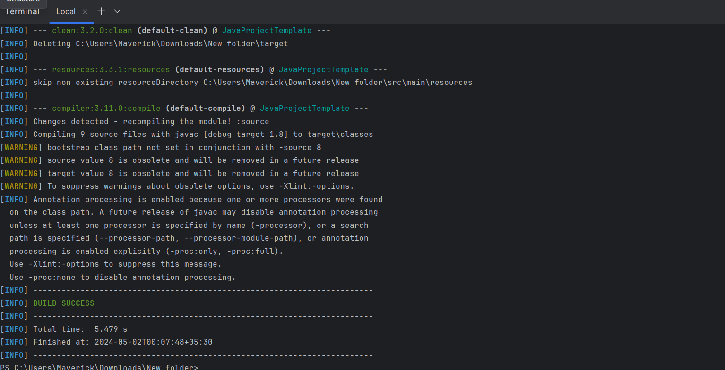

2. Run **mvn clean test**

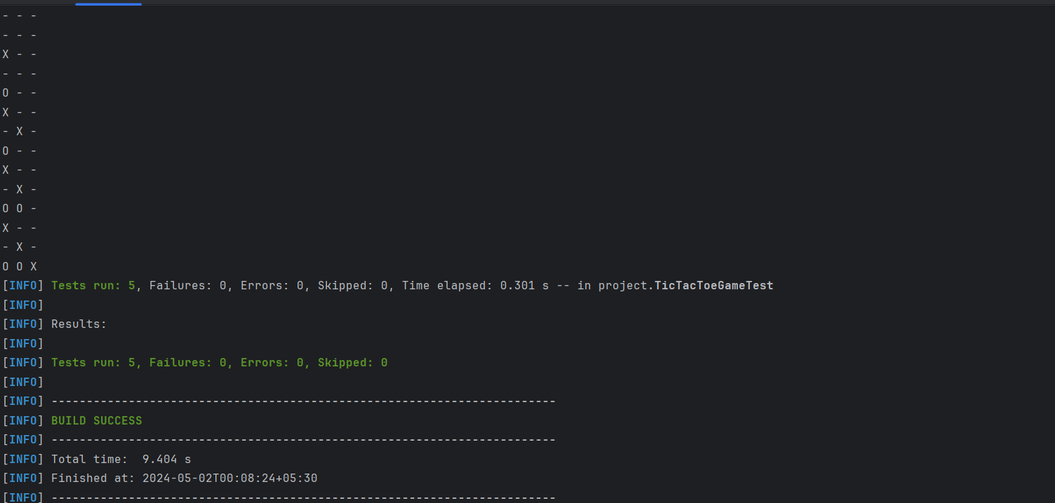

3 . run **mvn spotbugs:gui**

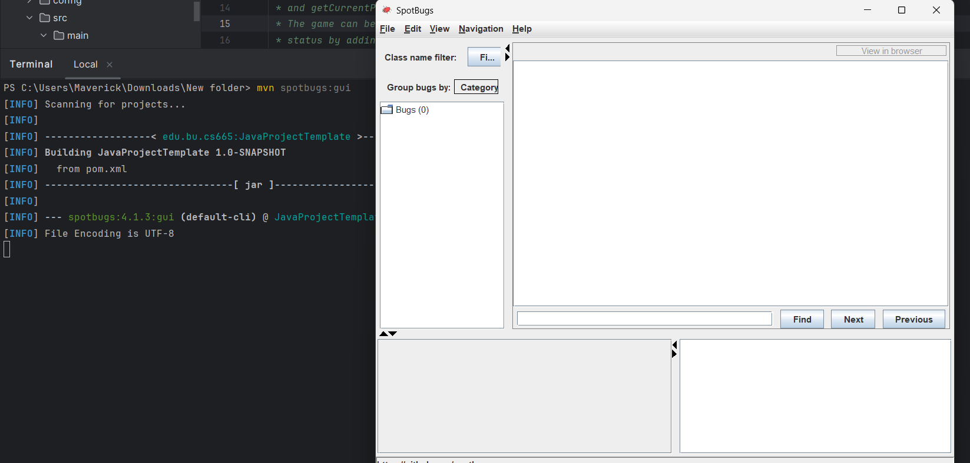

4 . run  **mvn checkstyle:checkstyle**



